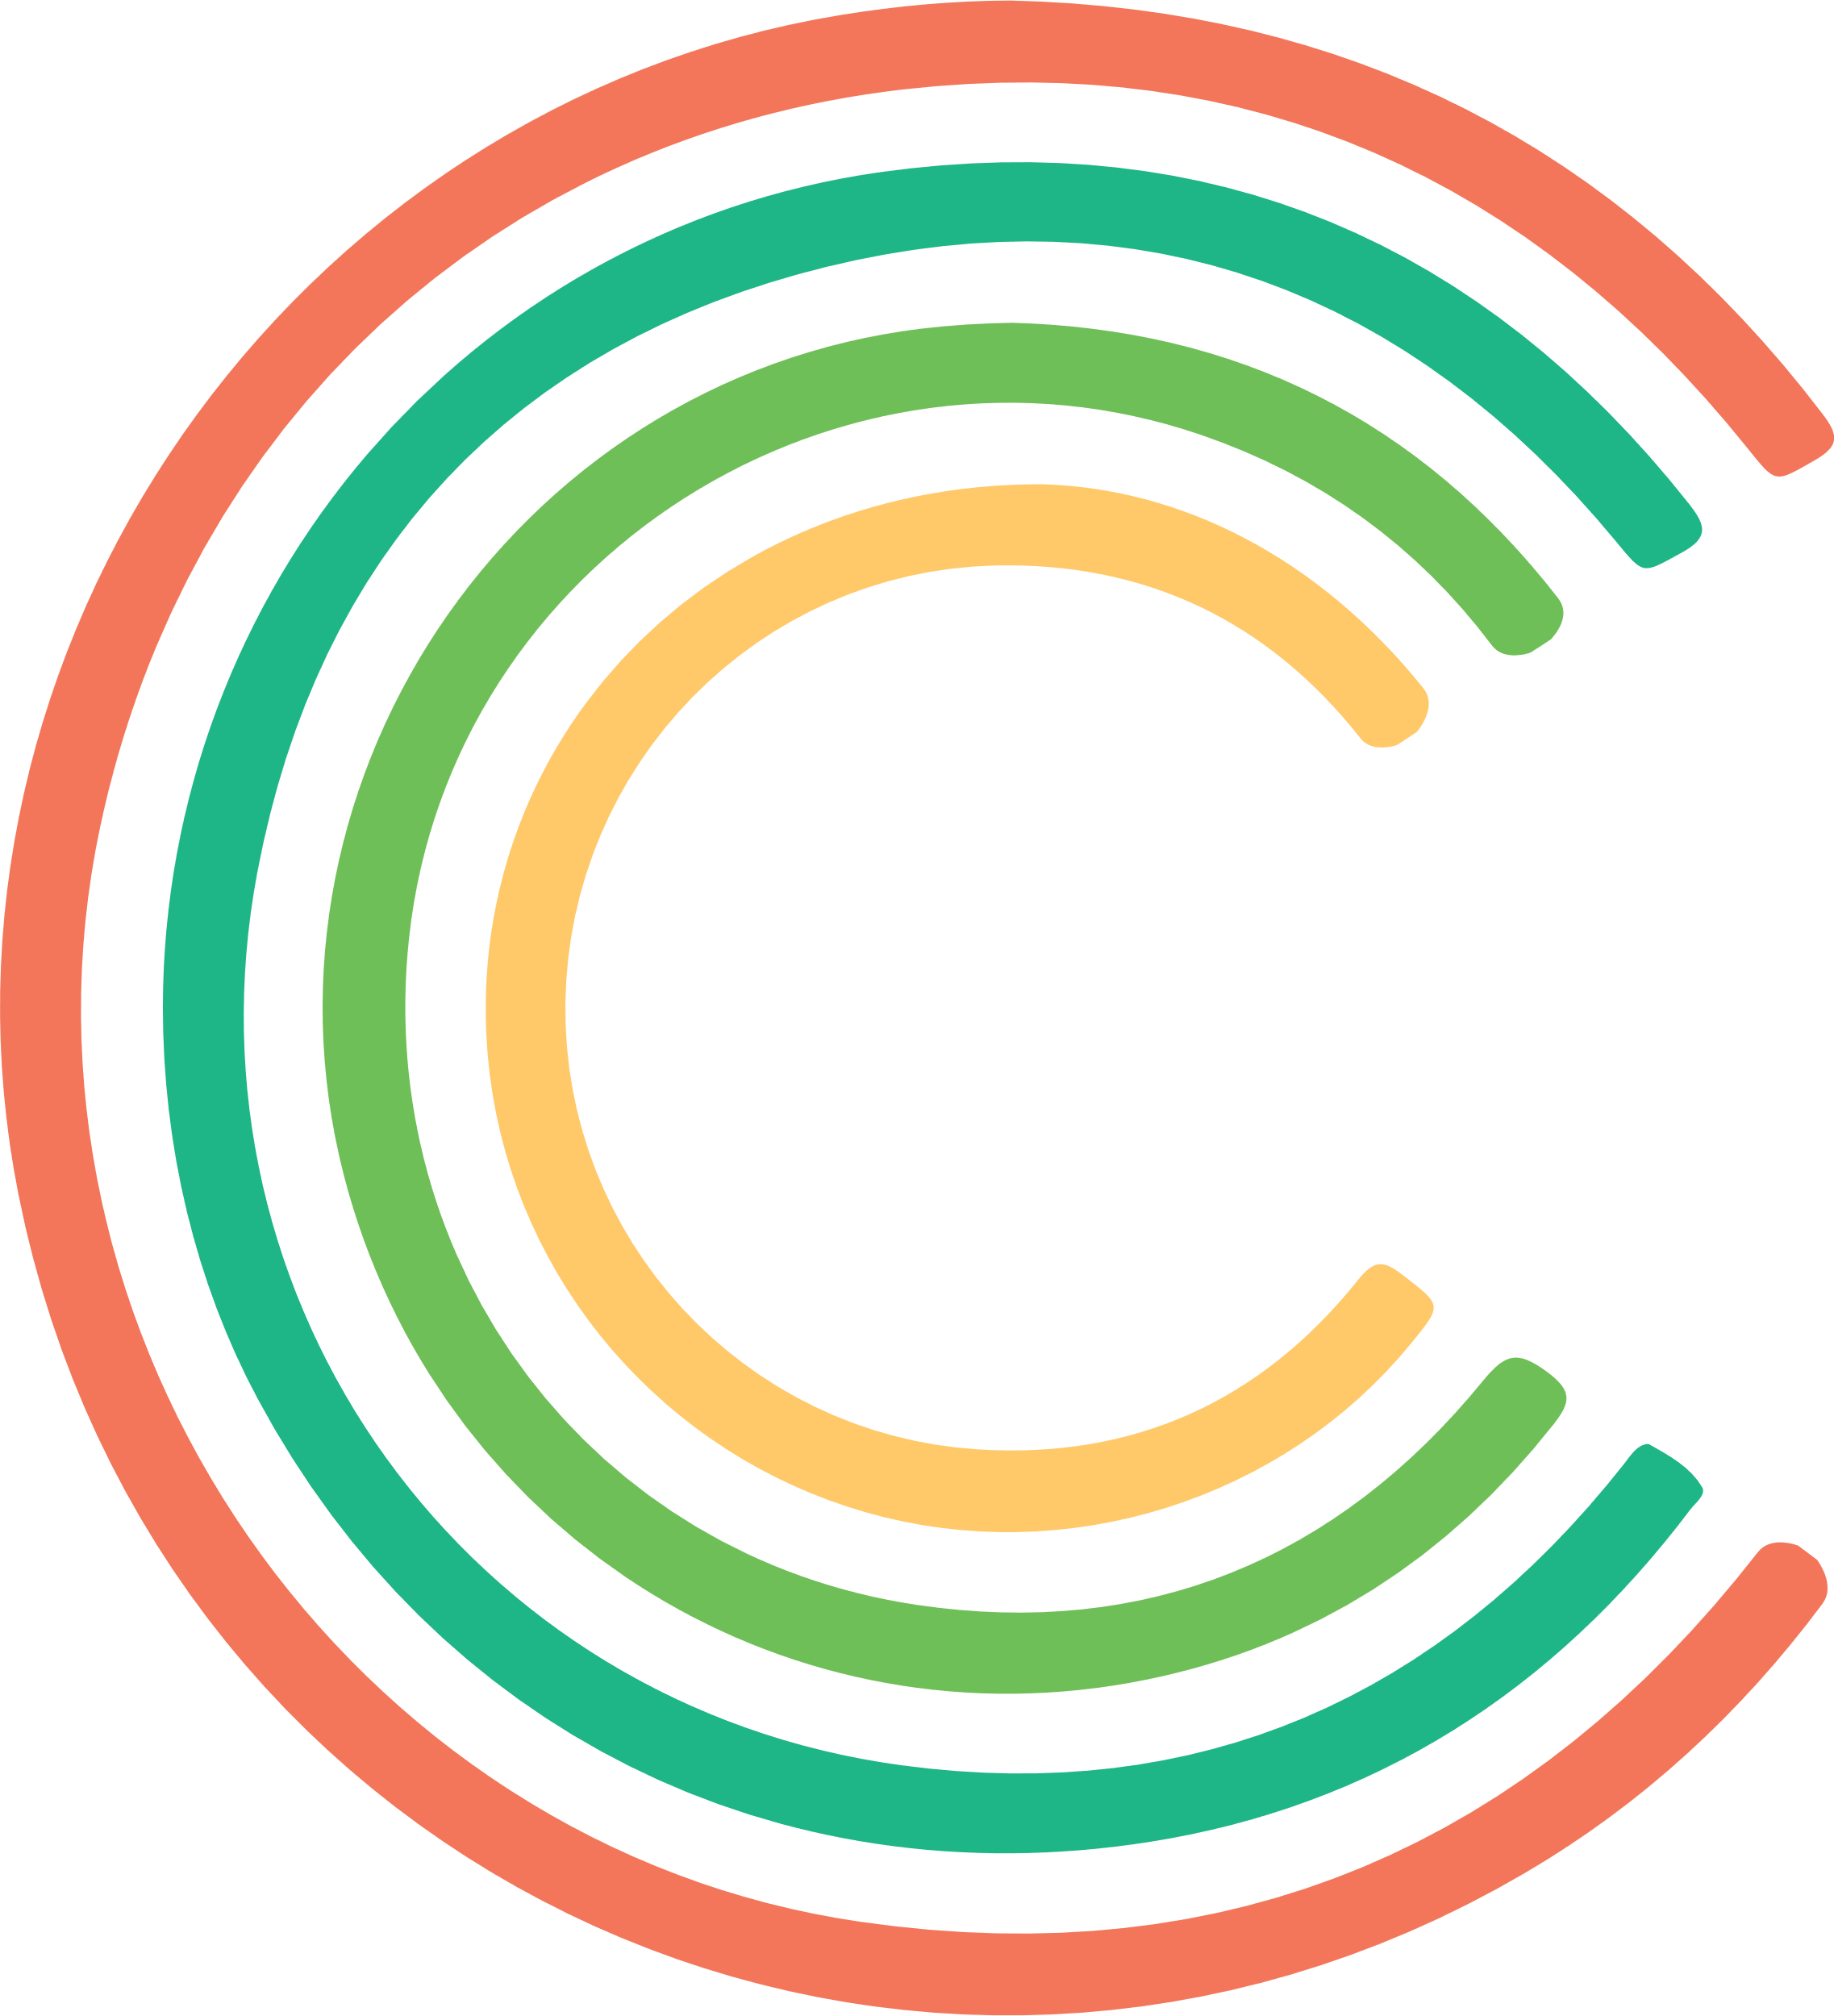

Florence Nightingale Foundation Leadership Programme – quality improvement workshop
Dear Participant,
We are looking forward to meeting you for our quality improvement learning session. We aim to create a fun and interactive learning environment for everyone.
As our session is interactive and you will be working in small groups to explore some of the tools and techniques, we need you to make sure you are able to fully participate on the day. Some of the resources you need are in the attached resource pack, and others you will need to make sure that you have on the day.
Objectives for the session
- Understand the Plan Do Study Act methodology, in the context of ‘improvement science’
- Know how to apply it to your clinical situation as a leader
- Develop plans to try it out in your clinical situation for your change project
Preparation ahead of the session
To get the most from our session please:
- Be prepared to talk about your improvement ideas to other participants
- Make sure you join us in a room where you can talk and laugh, without disturbing anyone else who is not on the course
- Ensure that your IT is set up to use Zoom and you have the right equipment to be heard as well being able to hear what we and other participants say (e.g. most desktop computers need a microphone).
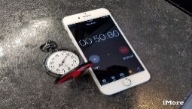
Materials to have on the day
- Make sure that you have at least four different coins
- A timer (stop watch or your phone)
- The printed information in this pack
You will be working in teams with the other participants on the day as our experience is that this is the best way to learn about quality improvement. A bit of preparation will make sure you don’t let anyone down.
Please contact academy@florence-nightingale-foundation.org.uk if you need help or to test your IT equipment ahead of the session.
See you soon,

Claire Henry and Susanna Shouls, Claire Henry Associates
clairehenryassociates.co.uk

