**Scholars Programme 2023:**

**Emerging Strategic Leaders**

**Day 1: 4th July 2023**

|  |  |
| --- | --- |
| **Timing** | **Content** |
| From 9.30 | **Registration & Refreshments** |
| 10.00 | Welcome, introductions and overview of the Module |
| 10.30 | Developing our learning community: Professional lifelines |
| 11.35 | **COFFEE BREAK** |
| 11.55 | Sharing perspectives on leadership |
| 12.25 | Leadership Energies |
| 13.00 | **LUNCH** |
| 13.50 | Leadership Modes |
| 15.00 | **BREAK** |
| 15.15 | Exploring Power, Authority and Influence |
| 16.45 | Closing Plenary: Key Insights from the Day |
| 17.00 | **CLOSE** |

**Day 2: 5th July 2023**

|  |  |
| --- | --- |
| **Timing** | **Content** |
| From 8.30 | **Registration & Refreshments** |
| 9.00 | Check in & Overview of Day 2 |
| 9.20 | Increasing your leadership impact: part 1 |
| 10.40 | **BREAK** |
| 11.00 | Increasing your leadership impact: part 2 |
| 11.45 | Guest Speaker (*TBC*) |
| 13.00 | **LUNCH** |
| 13.50 | Appreciative Conversations |
| 15.00 | **BREAK** |
| 15.15 | Anchoring Learning |
| 15.50 | Final Reflections |
| 16.00 | **CLOSE** |

Facilitator Biographies

Mark Patterson, Senior Consultant, Leadership and Organisational Development, The King’s Fund

Sarah Garrett, Leadership Associate, Leadership and Organisational Development, The King’s Fund

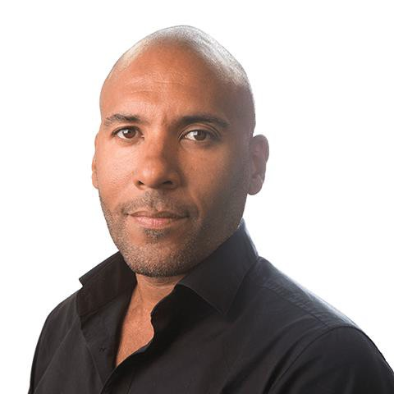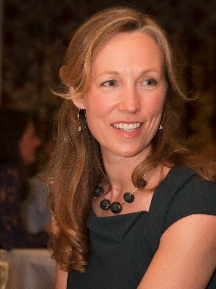

Mark joined The King’s Fund in May 2018 as a Senior Consultant in leadership and organisational development.

Before joining the Fund, he was the National Lead for Organisational Development with Public Health England, Associate Director for the South West Strategic Health Authority and a Senior Policy Lead for the Department Health, and Care Services Improvement Partnership. Mark began his career as a Social Worker before moving into organisational development, leadership development and coaching.

He has post-graduate management qualifications in Social Work, Executive Coaching, Group Action Learning, and an MSc in Leadership and Coaching.

Mark worked on development and service improvement projects within both the public, private and university sectors.

Mark is accomplished facilitator, educator, and coach. Confident in supporting strategic change, service improvement, leadership initiatives, and organisational development interventions.

Mark has a wealth of experience of supporting teams and leaders operating in complex system and has supported a range of leadership and team coaching interventions across the health and social care system.

Sarah is a Leadership Associate with The King’ s Fund and a freelance consultant in improvement and patient safety. Her King’s Fund work includes the Senior Leaders Programme for Cambridge University Hospitals NHS Foundation Trust, the Florence Nightingale Fellowship programme and the Senior Clinical Leaders Programme.

With a background in frontline NHS management, Sarah has spent much of her career working nationally on new approaches to improving quality, safety and patient experience. She was a founding member of the NHS Clinical Governance Support Team, national manager of the *Pursuing Perfection* initiative with the Institute of Healthcare Improvement and NHS Modernisation Agency, and is co-author of the NHS Institute book, *Thinking Differently*. She was a core team member of the national *Patient Safety First* campaign and, more recently, the *Sign up to Safety* campaign.

Sarah’s international work has included programmes on leadership for improvement and innovation with the New Zealand Ministry of Health and the Leadership and Quality Academy for Legacy Health System in the United States. She is guest faculty for the Washington State Hospital Association’s Executive Safety Academy and the Canadian Patient Safety Institute.