**Scholars Programme 2023:**

**Senior & Global Scholars**

**Day 1: 20th July 2023**

|  |  |
| --- | --- |
| **Timing** | **Content** |
| From 9.30 | **Registration & Refreshments** |
| 10.00 | Welcome, introductions and overview of the Module |
| 10.30 | Developing the learning community: Professional Lifelines  **(with coffee break)** |
| 12.10 | Leading in Systems: Exploring Dilemmas, Polarities and Conflict |
| 13.00 | **LUNCH** |
| 14.00 | Exploring Dilemmas, Polarities and Conflict continued |
| 15.50 | **BREAK** *(timing may flex)* |
| 16.05 | Developing Inquiry skills |
| 17.05 | Closing Plenary |
| 17.15 | **CLOSE OF DAY 1** |

**Day 2: 21st July 2023**

|  |  |
| --- | --- |
| **Timing** | **Content** |
| From  8.30 | **Arrival & Coffee** |
| 9.00 | Check in & Overview of Day 2 |
| 9.20 | Exploring Power, Authority and Influence |
| 10.30 | **BREAK** *(timing may flex)* |
| 10.50 | Leadership and Power |
| 11.45 | Guest Speaker (*TBC*) |
| 13.00 | **LUNCH** |
| 13.50 | Appreciative Conversations |
| 15.10 | **BREAK** *(timing may flex)* |
| 15.20 | Anchoring Learning |
| 15.50 | Closing Plenary |
| 16.00 | **CLOSE OF DAY 2** |

Facilitator Biographies

Sarah Garrett, Leadership Associate, Leadership and Organisational Development, The King’s Fund

Dr David Naylor Prof, MA, PGDip

Leadership Associate, Leadership and Organisational Development, The King’s Fund

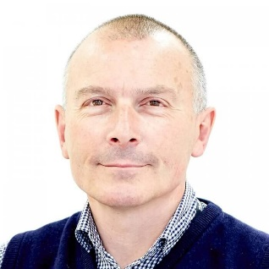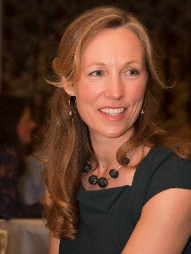

David is a director of a consultancy practice researching and developing practical interventions to mitigate the effects of bullying and incivility for individuals, teams and services. He has lead projects at a senior level in the NHS and Civil Service. This work builds on his doctoral research into the necessity and difficulty of being ‘constructively awkward’ in organisations; a two-year secondment to the NHS Sign up to Safety Campaign; and a long career in leadership and organisational development at The King’s Fund.

At The Kings Fund, David co-directed twelve cohorts of the Top Manager programme and led various senior leadership and board development projects.

Sarah is a Leadership Associate with The King’ s Fund and a freelance consultant in improvement and patient safety. Her King’s Fund work includes the Senior Leaders Programme for Cambridge University Hospitals NHS Foundation Trust, the Florence Nightingale Fellowship programme and the Senior Clinical Leaders Programme.

With a background in frontline NHS management, Sarah has spent much of her career working nationally on new approaches to improving quality, safety and patient experience. She was a founding member of the NHS Clinical Governance Support Team, national manager of the *Pursuing Perfection* initiative with the Institute of Healthcare Improvement and NHS Modernisation Agency, and is co-author of the NHS Institute book, *Thinking Differently*. She was a core team member of the national *Patient Safety First* campaign and, more recently, the *Sign up to Safety* campaign.

Sarah’s international work has included programmes on leadership for improvement and innovation with the New Zealand Ministry of Health and the Leadership and Quality Academy for Legacy Health System in the United States. She is guest faculty for the Washington State Hospital Association’s Executive Safety Academy and the Canadian Patient Safety Institute.