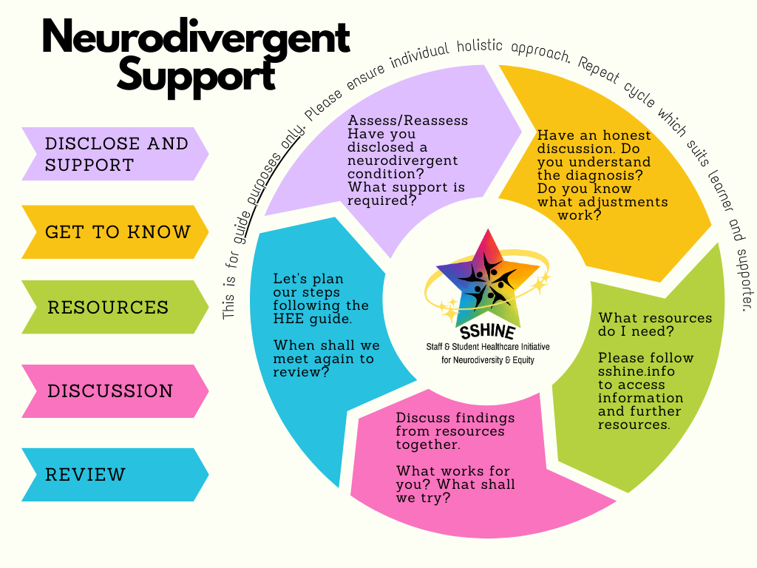

**Guidance for support cycle:-**

This support cycle is for guidance only. Please review your policies in addition to this tool. This tool was created to simplify the key steps, whilst planning and reviewing support, and is aimed at individuals who are responsible for implementing support on behalf of an individual.

**Disclose and support**

This step can be a scary moment for an individual for several reasons. To highlight some, an individual may have had a previous negative experience, they may not be aware they have a neurodivergent condition, and they may not be aware of what support is available. Please use a compassionate and holistic approach.

**Get to know**

This step is centred on getting to know one another. What in particular are the main worries and concerns? Is there a previous history of what worked well and what did not work so well? What does the individual feel they may need in terms of support, do they know? What support can you offer?

**Resources**

What does your governing body suggest? Does your organisation have their resources and policies? This step is a chance for you to explore together and share resources you may already be aware of. Health Education England (HEE) supported SSHINE in creating a resource that provides tips and tricks for managing a variety of difficulties one may encounter. This can be found in the further resources below.

**Discussion**

Bring this information together to make a plan moving forward. Are your findings similar? Have you previously tried something that has not worked? Use this section to plan your steps going forward and how much time you are allocating before a review is needed. Remember, the plan you make can be adjusted at any time.

**Review**

It is time to review our plan. Are both parties happy with the plan? Do both parties understand the plan? When shall we meet again to review? - How are things going? Have you tried something new and found that it does not work for you, that is OK. Did you use the HEE guide? Are the tips and tricks working or would you like to try something new? What else do you think we can do to support you? The design of the guidance is in a cycle to recognise that one glove does not fit all.